http://library.thinkquest.org/20922/text-only/why_vegan.htm
VEGAN PSA’s
MONDAY
Vegan Tidbit of the Day: Do you care about your health, animals and the environment? Consider learning more about veganism. Vegans are people who consume no animal products. Some health benefits to being a vegan are weight loss, lower cholesterol and blood pressure. Listen tomorrow for more on the positives of being a vegan.
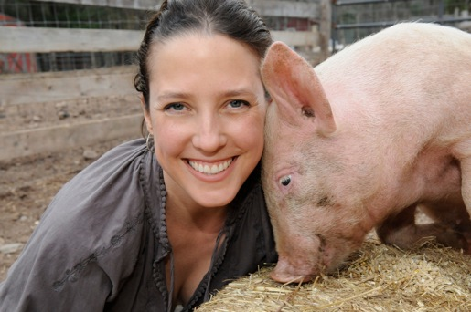
http://www.google.com/imgres?imgurl=http://3.bp.blogspot.com/_WtnEJZGWwX8/S8Hvn_HkmXI/AAAAAAAAAo8/ZaWbpcXXhGM/s1600/-14.jpg&imgrefurl=http://kissmyvegan.blogspot.com/2010/04/interview-series-6-jenny-brown-of.html&usg=__RLV2tza1rPChPI-4vM-W8zLzmTk=&h=342&w=515&sz=63&hl=en&start=94&zoom=1&tbnid=Tf-zzjrFBu3DGM:&tbnh=158&tbnw=199&ei=dw_6TbizNIHAgQfK7cSOBQ&prev=/search%3Fq%3Dhealthy%2Bperson%2B%252B%2Bfarm%2Banimals%26hl%3Den%26client%3Dfirefox-a%26sa%3DG%26rls%3Dorg.mozilla:en-US:official%26biw%3D1268%26bih%3D824%26gbv%3D2%26tbm%3Disch&itbs=1&iact=hc&vpx=360&vpy=335&dur=399&hovh=158&hovw=199&tx=134&ty=57&page=5&ndsp=23&ved=1t:429,r:12,s:94&biw=1268&bih=824


http://www.google.com/imgres?imgurl=http://intelligentguidetoms.files.wordpress.com/2010/01/healthy-planet1.jpg&imgrefurl=http://intelligentguidetoms.wordpress.com/2010/01/01/eating-to-beat-ms-saves-the-planet-and-your-pocketbook-too/&usg=__shMhyaf_uNGr2aP-_CuBNgqKOC8=&h=565&w=850&sz=155&hl=en&start=0&zoom=1&tbnid=64CbC7tfpz9t6M:&tbnh=147&tbnw=195&ei=jRf6TaXtA5KRgQf91bmLBQ&prev=/search%3Fq%3Dhealthy%2Bplanet%26um%3D1%26hl%3Den%26client%3Dfirefox-a%26rls%3Dorg.mozilla:en-US:official%26gbv%3D2%26biw%3D1268%26bih%3D824%26tbm%3Disch&um=1&itbs=1&iact=rc&dur=349&page=1&ndsp=24&ved=1t:429,r:17,s:0&tx=56&ty=114&biw=1268&bih=824

TUESDAY
Vegan Tidbit of the Day: Veganism is a strict form of vegetarianism-which means that a person does not consume any animal products. If you are concerned about your health, cutting back on the consumption of animal-based foods is as important as quitting smoking or regular exercise. And many vegans don’t believe in using animal products, either, such as leather, wool, honey and products containing slaughterhouse ingredients. Most try to avoid animal-tested products found in shampoos, cosmetics and paints, too. Tomorrow: The human and environmental advantages to veganism.
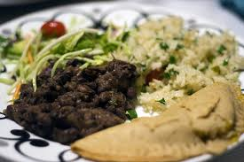
http://www.google.com/imgres?imgurl=http://farm4.static.flickr.com/3372/4600599014_78e647015b.jpg&imgrefurl=http://www.flickr.com/photos/cheapandplastic/4600599014/&usg=__HLIRphcruZMT23_B4zSPtfpxl8k=&h=333&w=500&sz=108&hl=en&start=24&zoom=1&tbnid=6sDD1_d0yQ0WbM:&tbnh=151&tbnw=210&ei=Yxj6TZaUIYHYgQf6mpSIBQ&prev=/search%3Fq%3Dvegan%2Bmeal%26um%3D1%26hl%3Den%26client%3Dfirefox-a%26rls%3Dorg.mozilla:en-US:official%26gbv%3D2%26biw%3D1268%26bih%3D824%26tbm%3Disch&um=1&itbs=1&iact=hc&vpx=371&vpy=483&dur=131&hovh=183&hovw=275&tx=156&ty=138&page=2&ndsp=20&ved=1t:429,r:1,s:24&biw=1268&bih=824


http://www.google.com/imgres?imgurl=http://www.becomegorgeous.com/img/user/7/4/4/e/angitia41/lists/complete_vegan_cosmetics/1101_large.jpg&imgrefurl=http://www.becomegorgeous.com/user/items/zuzu_luxe_natural_eyeshadow_vegan_cosmetics_eye_makeup-1101.html&usg=__HbdzEa0sNGoJ_VuEPJbLI_wsxvk=&h=186&w=200&sz=6&hl=en&start=21&zoom=0&tbnid=Ay_oM8F-yNTjtM:&tbnh=97&tbnw=104&ei=8iD6TfHRA8G_gQfg9-WGBQ&prev=/search%3Fq%3Dvegan%2Bcosmetics%26um%3D1%26hl%3Den%26client%3Dfirefox-a%26rls%3Dorg.mozilla:en-US:official%26gbv%3D2%26biw%3D1268%26bih%3D824%26tbm%3Disch&um=1&itbs=1&iact=rc&dur=383&page=2&ndsp=24&ved=1t:429,r:22,s:21&tx=60&ty=46&biw=1268&bih=824

WEDNESDAY
Vegan Tidbit of the Day: Huge amounts of grain, water and farmland are needed to grow the food for farm animals. These resources could be freed up by small reductions in meat consumption. Look at it this way: if each American reduced his or her meat consumption by one meat dish a week, enough grain would be saved to feed 25million people-the number estimated to go hungry in the U.S. each day. According to the website Veganet, the beef in one Big Mac represents enough wheat to produce five loaves of bread. And consider this: The massive waste produced by livestock threatens waterways worldwide. According to the Environmental Protection Agency, the world’s livestock herds are the largest source of human-induced emissions of methane-a greenhouse gas contributing to climate change. Tomorrow: The toll taken on animals.
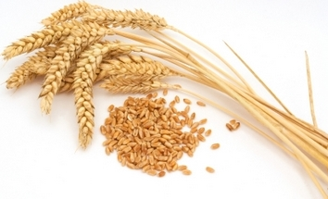
http://www.google.com/imgres?imgurl=http://www.healthbanquet.com/images/wheat-stem-and-grain.jpg&imgrefurl=http://www.healthbanquet.com/wheatgrass-life-cycle.html&usg=__YLQwwgLSYjrLCO4_ibMZjcKPZiQ=&h=215&w=354&sz=69&hl=en&start=0&zoom=1&tbnid=NIz-vnoncFvBTM:&tbnh=104&tbnw=172&ei=jRn6TcThJNTSgQfQ3NmPBQ&prev=/search%3Fq%3Dwheat%2Bgrains%26um%3D1%26hl%3Den%26client%3Dfirefox-a%26rls%3Dorg.mozilla:en-US:official%26gbv%3D2%26biw%3D1268%26bih%3D824%26tbm%3Disch&um=1&itbs=1&iact=hc&vpx=485&vpy=228&dur=3233&hovh=172&hovw=283&tx=145&ty=108&page=1&ndsp=27&ved=1t:429,r:

THURSDAY
Vegan Tidbit of the Day: Animal cruelty is predominant throughout the world, in slaughterhouses, egg and dairy industries, and animal testing labs. Few people realize just what these conditions are like. Even fewer people know that these conditions are not a thing of the past - they exist today! Some people become vegetarian due to the cruelty of slaughterhouses but don't realize how the chickens and dairy cows of the egg and dairy industries are treated. Most of the industries' animals are kept in extremely small confinement. Chickens live their entire lives in a small cage. Cows leave their fenced enclosures only to be slaughtered. Dairy cows may never be released. To cut costs, some farmers are adding a variety of questionable waste substances to their livestock and poultry feed. It is cruel to feed animals this, but do you want to eat the animals that have been eating this? So what can you do about all of this? Listen tomorrow to find out what you can do to make a change.
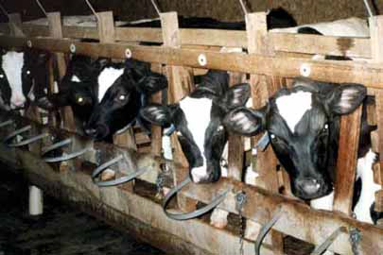
http://www.google.com/imgres?imgurl=http://www.animaldefense.com/A_images/vealcrates.jpg&imgrefurl=http://www.animalabusersspotlight.com/factory-farm-cruelty.php&usg=__sU-tNqg4YV0pGsIGcF8ovG1ZHXg=&h=270&w=405&sz=41&hl=en&start=20&zoom=1&tbnid=sW5-x3eOweJ4xM:&tbnh=151&tbnw=191&ei=URT6TaCeJoecgQeF2ZieBQ&prev=/search%3Fq%3Dpenned%2Bdairy%2Bcows%26hl%3Den%26client%3Dfirefox-a%26rls%3Dorg.mozilla:en-US:official%26biw%3D1268%26bih%3D824%26gbv%3D2%26tbm%3Disch&itbs=1&iact=hc&vpx=329&vpy=294&dur=445&hovh=183&hovw=275&tx=141&ty=121&page=2&ndsp=23&ved=1t:429,r:18,s:20&biw=1268&bih=824

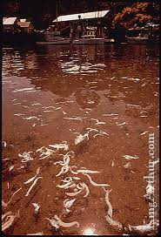
http://www.google.com/imgres?imgurl=http://membrane.com/oil/pictures/water_pollution.jpg&imgrefurl=http://meepozopw.blogspot.com/2007/05/land-pollution-various-kinds.html&usg=__JkEh5mKHjwnHf7i8b8gAtWtH3t4=&h=600&w=409&sz=86&hl=en&start=0&zoom=1&tbnid=c1dKtotZCVG66M:&tbnh=157&tbnw=112&ei=byD6Tf2JGYjqgQeWjMmCBQ&prev=/search%3Fq%3Dfarm%2Bpolluted%2Briver%26um%3D1%26hl%3Den%26client%3Dfirefox-a%26sa%3DX%26rls%3Dorg.mozilla:en-US:official%26gbv%3D2%26biw%3D1268%26bih%3D824%26tbm%3Disch&um=1&itbs=1&iact=rc&dur=276&page=1&ndsp=21&ved=1t:429,r:1,s:0&tx=57&ty=155&biw=1268&bih=824
FRIDAY
Vegan Tidbit of the Day: In answer to yesterday’s question: So what can you do about all of this animal cruelty? Become a vegan. Abstaining from the consumption of animal products discourages the industry and shows your support for proper animal treatment. Try to eliminate all products that contain animal remains. Read labels before purchase. Find a reliable food source such as: growing your own garden; your local supermarket may have a health food department; dedicated local health food stores or co-ops; mail order sources. Probably the best way to become a vegan is through a decision that you will stop consuming non-vegan products on a particular day. From that day on, you should work toward eating healthy.
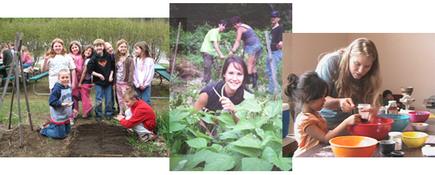
http://www.seedsofsolidarity.org/schoolgardens.html
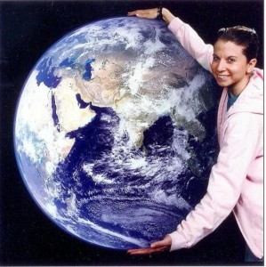
http://www.google.com/imgres?imgurl=http://www.gleegum.com/blog/wp-content/uploads/2009/10/Rob.Earth.edit-299x300.jpg&imgrefurl=http://www.gleegum.com/blog/2009/10/&usg=__yU4mjsiYu8KdCAFJwr_a4TIgrC4=&h=300&w=299&sz=37&hl=en&start=72&zoom=1&tbnid=ETVhGKrHH-3EBM:&tbnh=160&tbnw=159&ei=OxL6TdvMLIfUgAf5iq2jBQ&prev=/search%3Fq%3Dhealthy%2Bplanet%26hl%3Den%26client%3Dfirefox-a%26rls%3Dorg.mozilla:en-US:official%26biw%3D1268%26bih%3D824%26gbv%3D2%26tbm%3Disch&itbs=1&iact=rc&dur=336&page=4&ndsp=25&ved=1t:429,r:0,s:72&tx=113&ty=119&biw=1268&bih=824

